Alfred A. Knopf Celebrates its Centenary

By Nancy Lazarus on Oct. 2, 2015 - 3:00 PM

Hundreds of guests filled Astor Hall at the New York Public Library on Thursday evening to celebrate Alfred A. Knopf’s centennial anniversary. Borzoi dogs, the same breed that graces the publisher’s logo, welcomed the crowd on the red carpet. Even the heavy rain didn’t dampen the spirit of this momentous occasion.
Remarks by Knopf editor in chief Sonny Mehta, Knopf authors Robert Caro, Sharon Olds, James Ellroy and Toni Morrison, along with Mitchell Kaplan, co-founder of the Miami Book Fair International, highlighted the event. The evening culminated with a soulful song performed by Patti Smith, whose latest book, M Train, was reviewed by The New York Times the same day. Among many notable attendees: Sam Shepard, Renata Adler, Fran Lebowitz and Charlie Rose.
Sonny Mehta’s remarks reflected his gratitude to all those who have contributed to Knopf’s success. “Our predecessors defined what it is to be a publisher. Publishing books well sounds easy, but I only wish it were so. Thanks to all our friends: the booksellers, librarians, and the media. As for our authors, your work is the bedrock of Knopf, it always has been and always will be, and we’re proud to be your publisher.”
Robert Caro, with Knopf for 45 years, joked about his first book, when he carried over seven boxes containing the manuscript for The Power Broker. “We’re celebrating something rare and meaningful, since Knopf has endured with its basic standards and values unchanged”, he said “While so many in the book world have changed, Knopf has preserved as an institution, keeping its core identity intact. The 100th anniversary is an achievement truly worth celebrating.”
Mitchell Kaplan, about to mark the Miami Book Fair International’s 33rd year, said he recently came across a typescript with a prescient note from Mehta about a book that turned out to be The English Patient.
“Knopf’s remarkable history is about its attention to quality and the lofty taste of everyone associated with this storied publishing house. It’s never an issue of whether to carry a book by Knopf, it’s only a question of how many to buy,” Kaplan said.
Toni Morrison concluded her comments by saying, “It’s been a great ride and there is more to come.”
(Photos courtesy of Patrick McMullan Company)

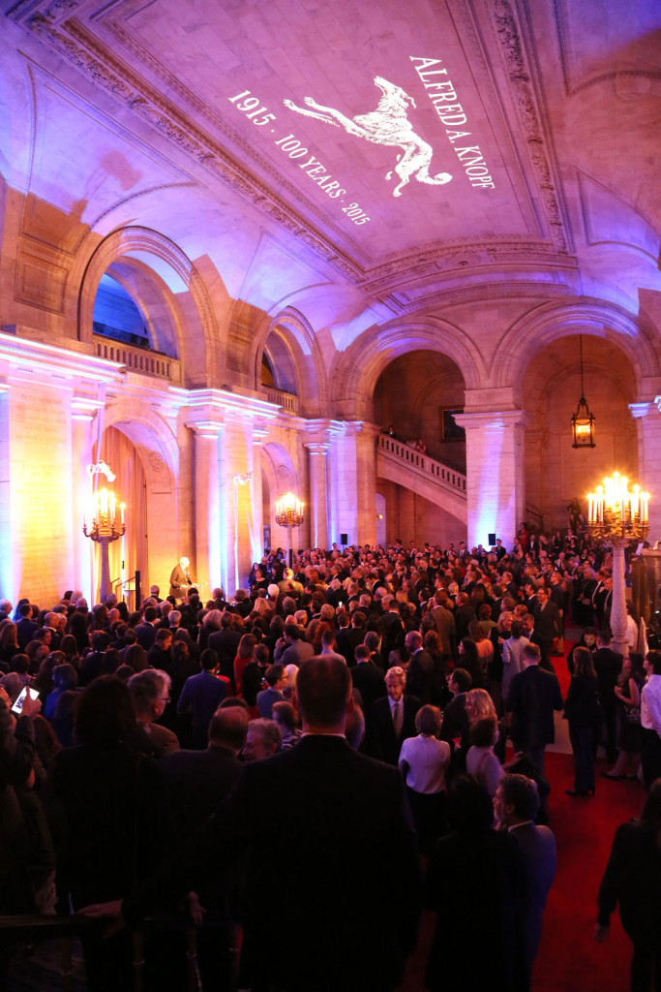

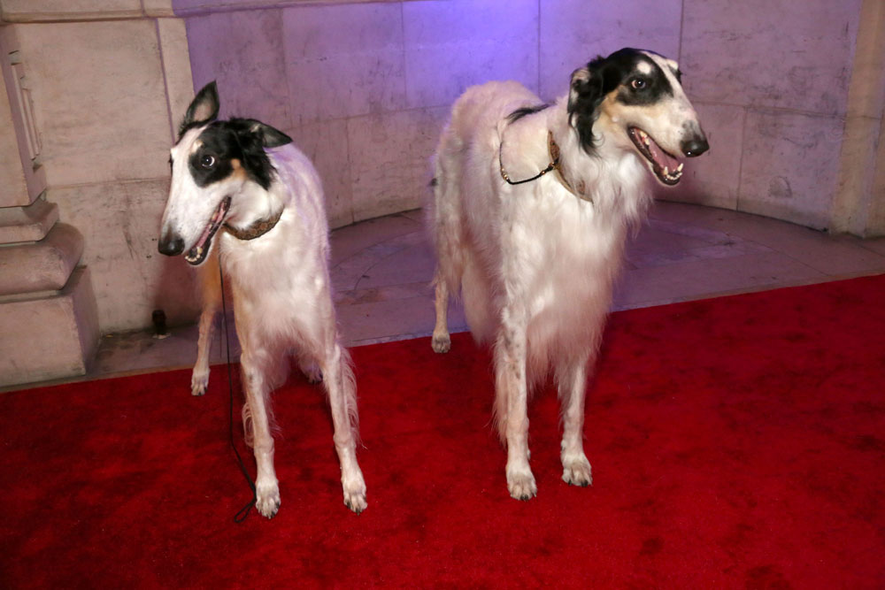
BORZOI DOGS

